| Course Name | ITD 2343 – Object Oriented Programming with C# |
| --- | --- |
| Instructor | Mark L. Pranger |
| Student Name | <Ezequiel Barrientos> |
| Due date | <10/31/25> |
| Grade | <grade earned here> |
| Grading Comments | <instructor comments here> |

Testing All Convert Buttons:

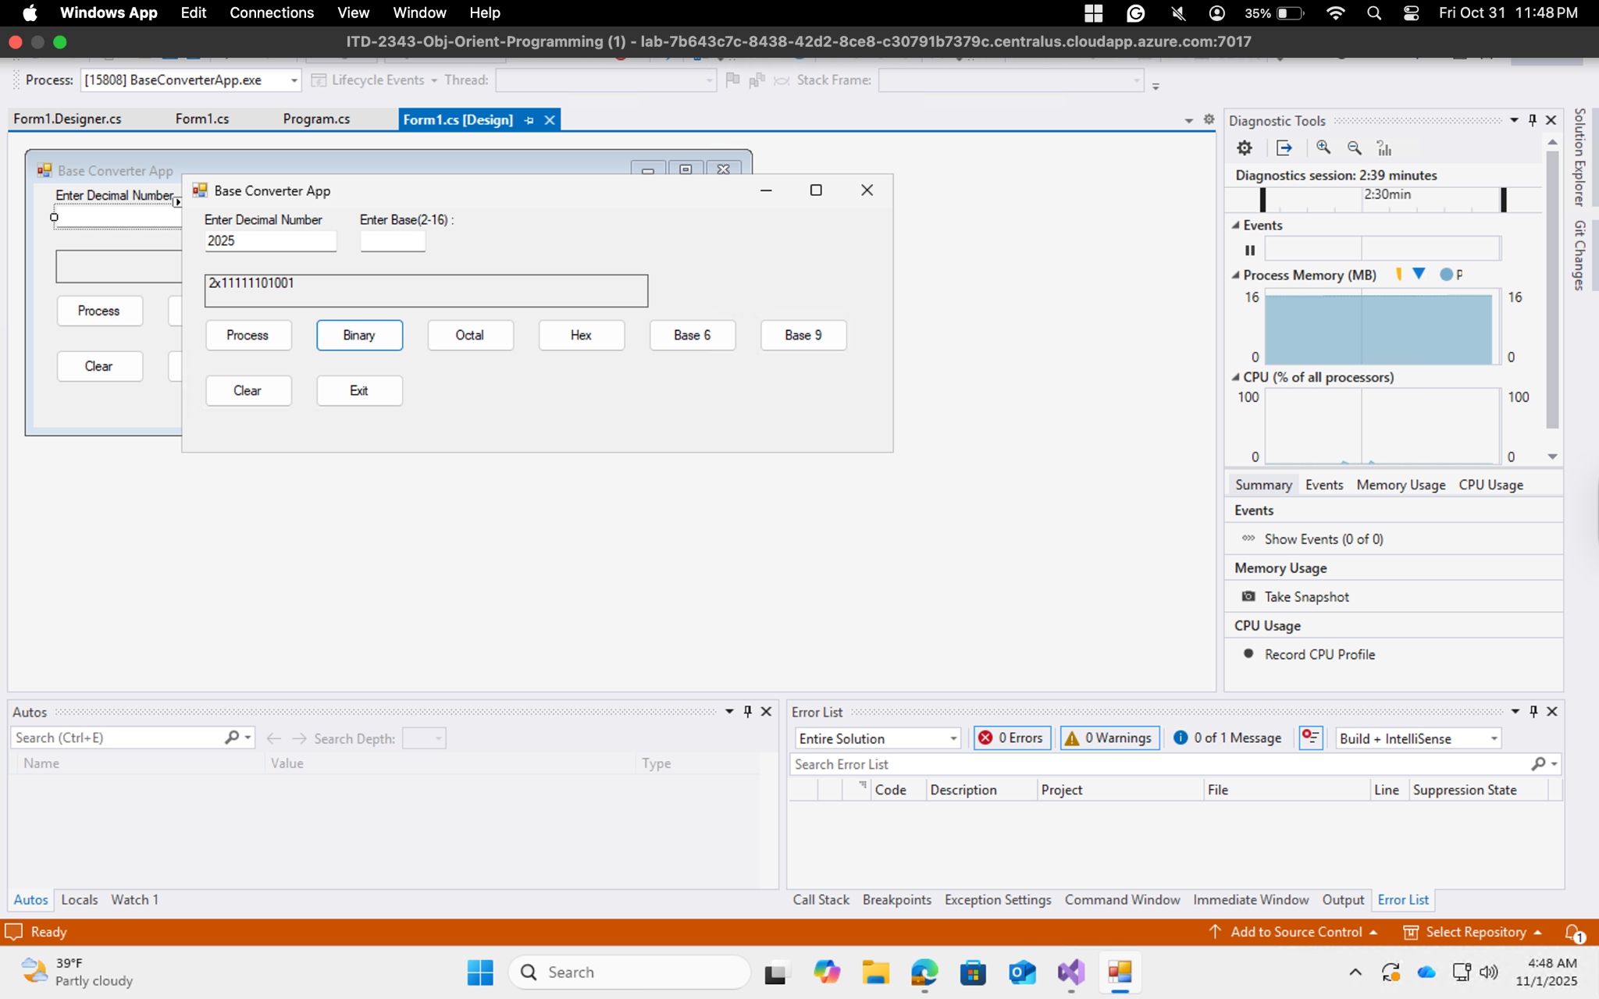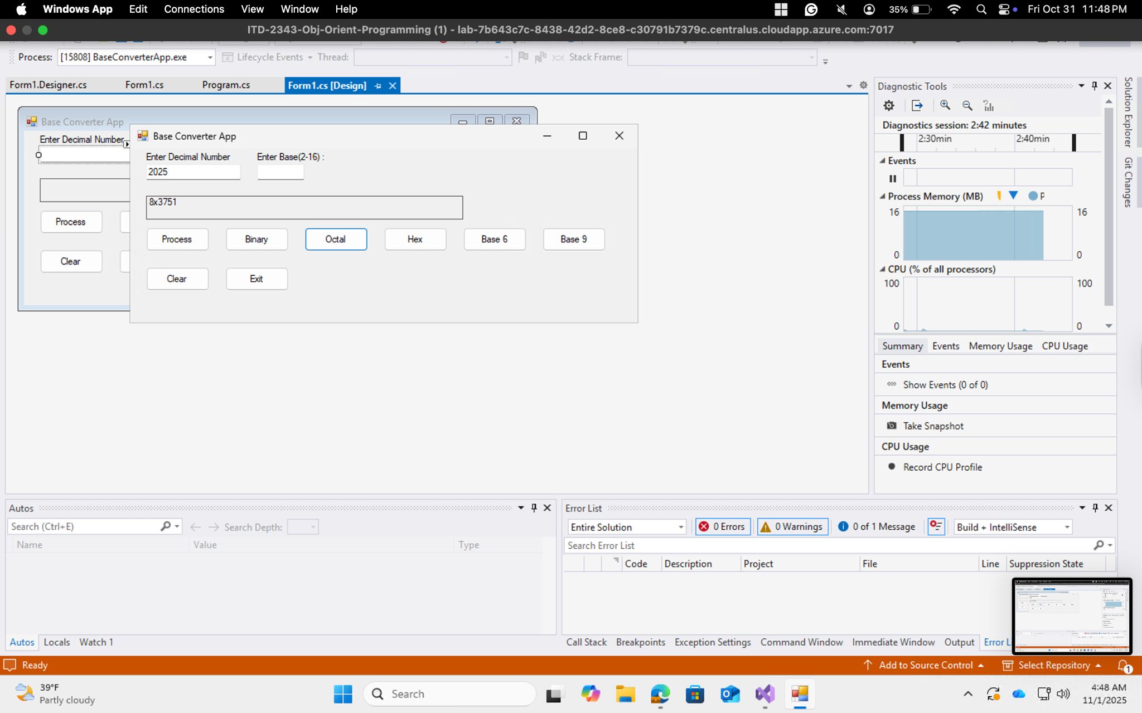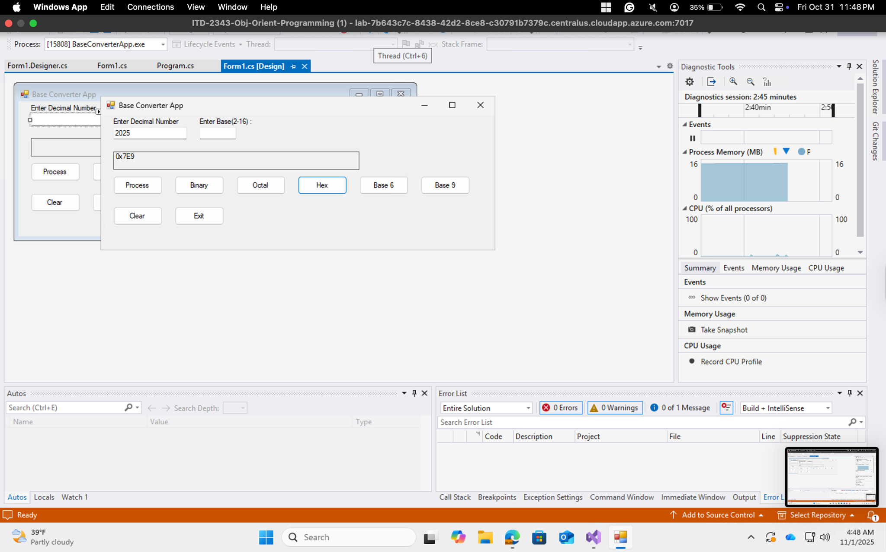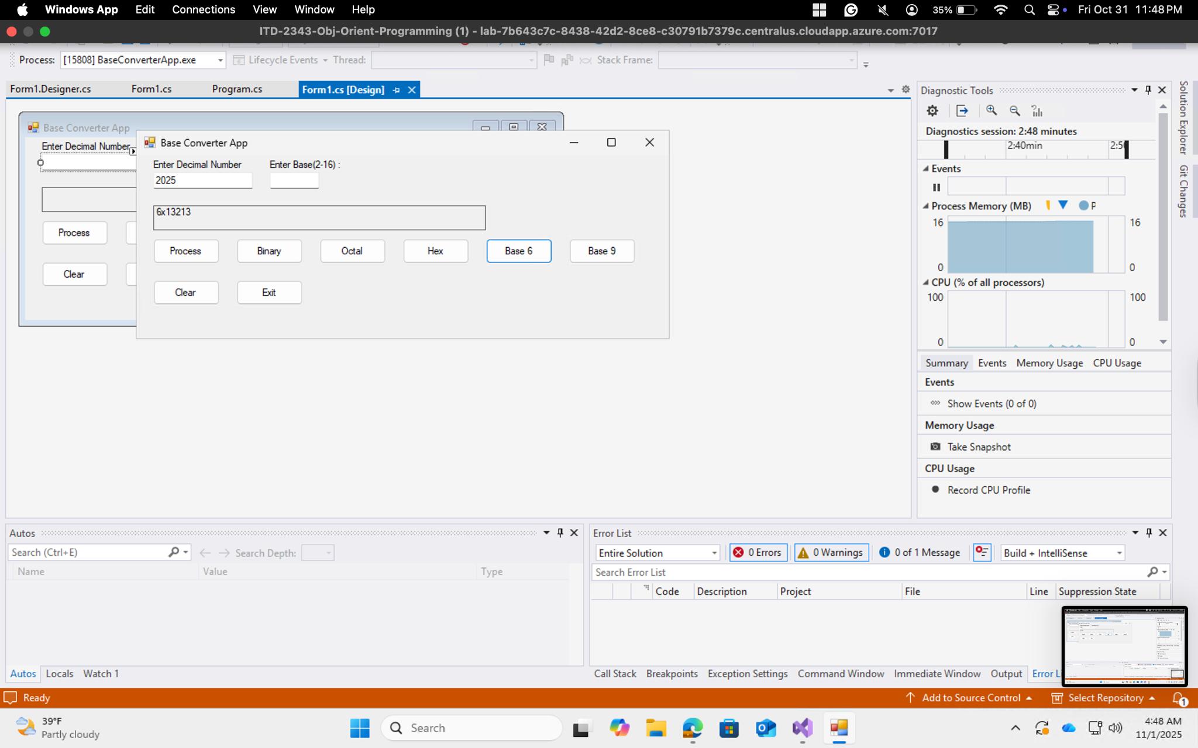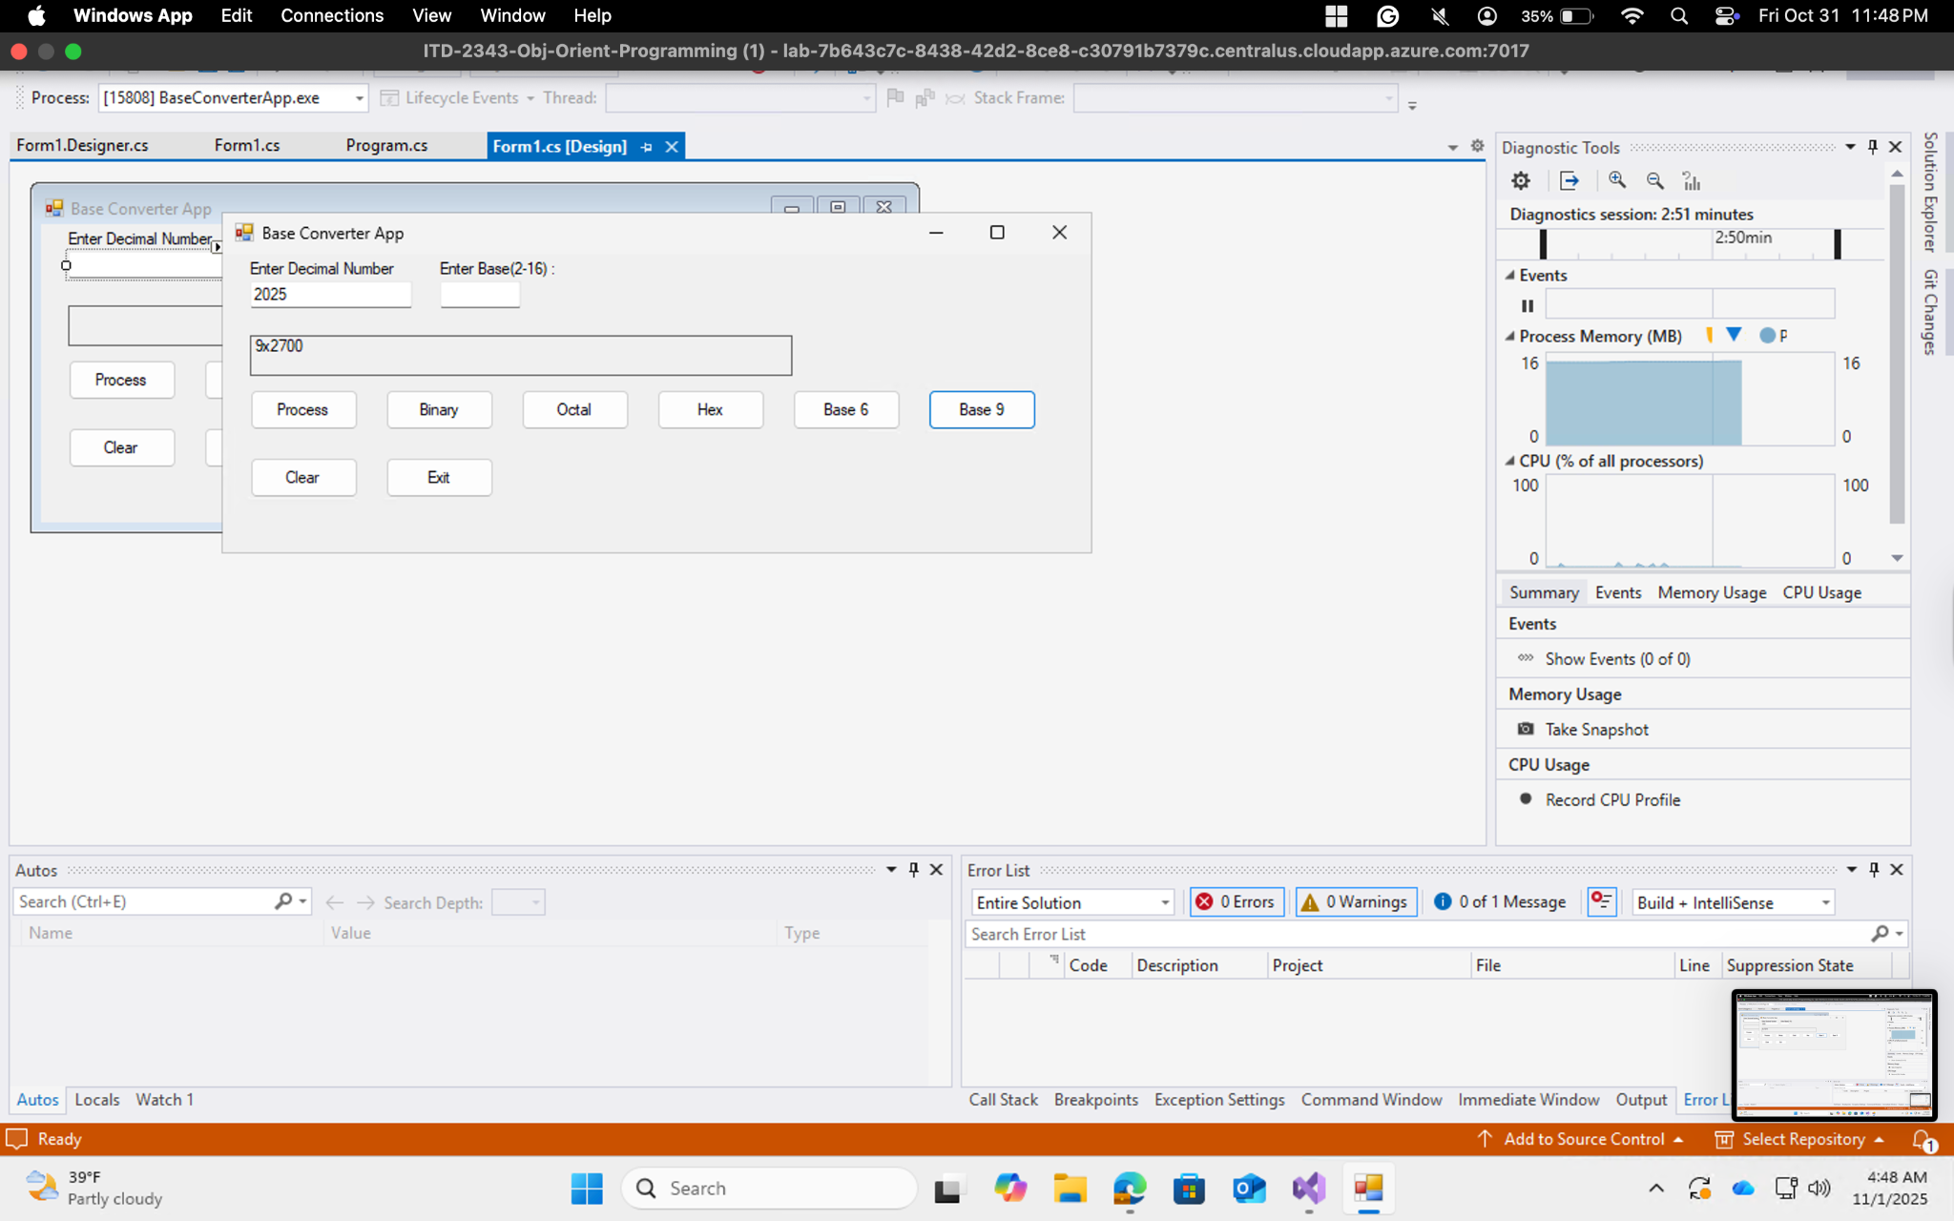

Test Process Button:

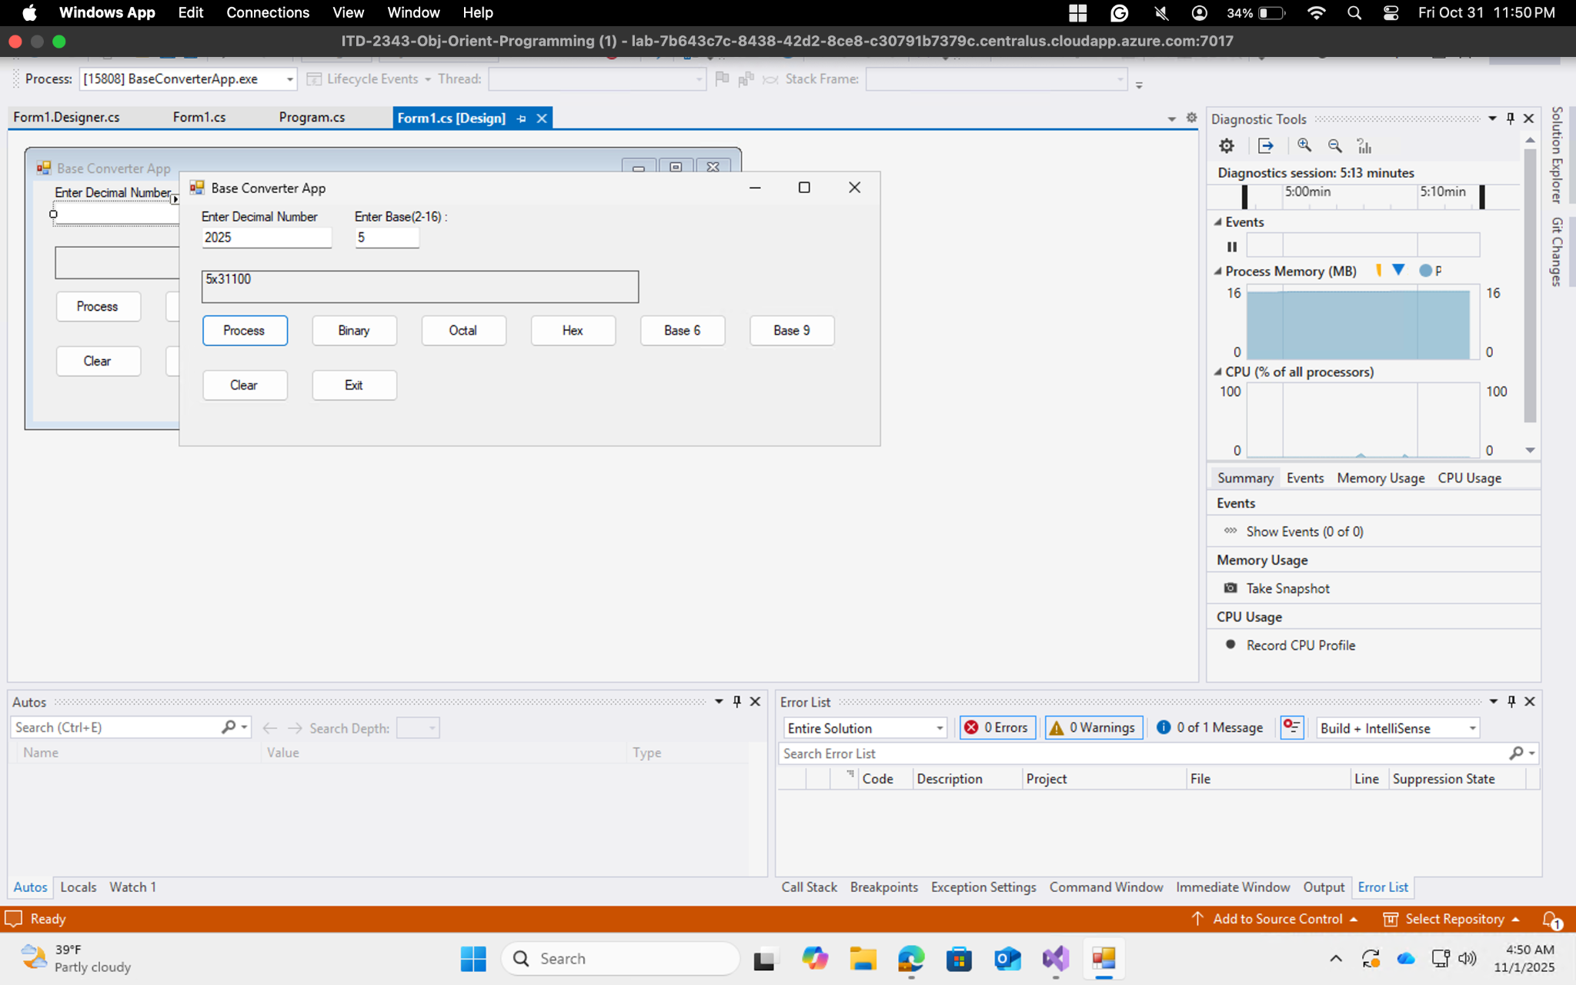

Invalid Test:

